# **Health Monitoring Wearable Device for Outdoor Hiking Activity**

## Clients

Mapua University, Self Made Project for Electronics Laboratory

## Objective / Goals / Purpose

The study aims to create a wearable health monitoring device using Arduino for hikers at high altitudes. It will monitor ambient temperature, atmospheric pressure, and heart rate. Specific goals include constructing the device itself, developing a GUI Interface using MIT App Inventor to receive data, and evaluating the device's effectiveness through measurements of temperature, air pressure, and heart rate.

## Technologies Used

Arduino, MIT app inventor, C/C++

## Description

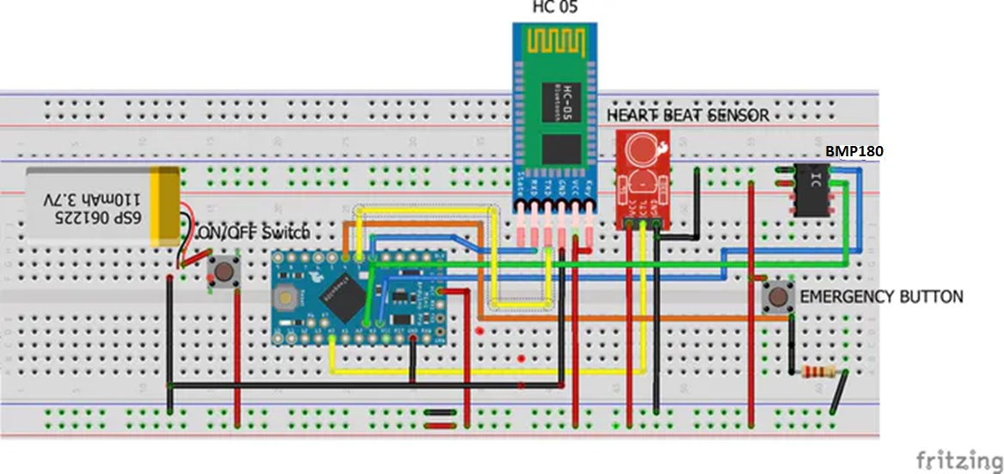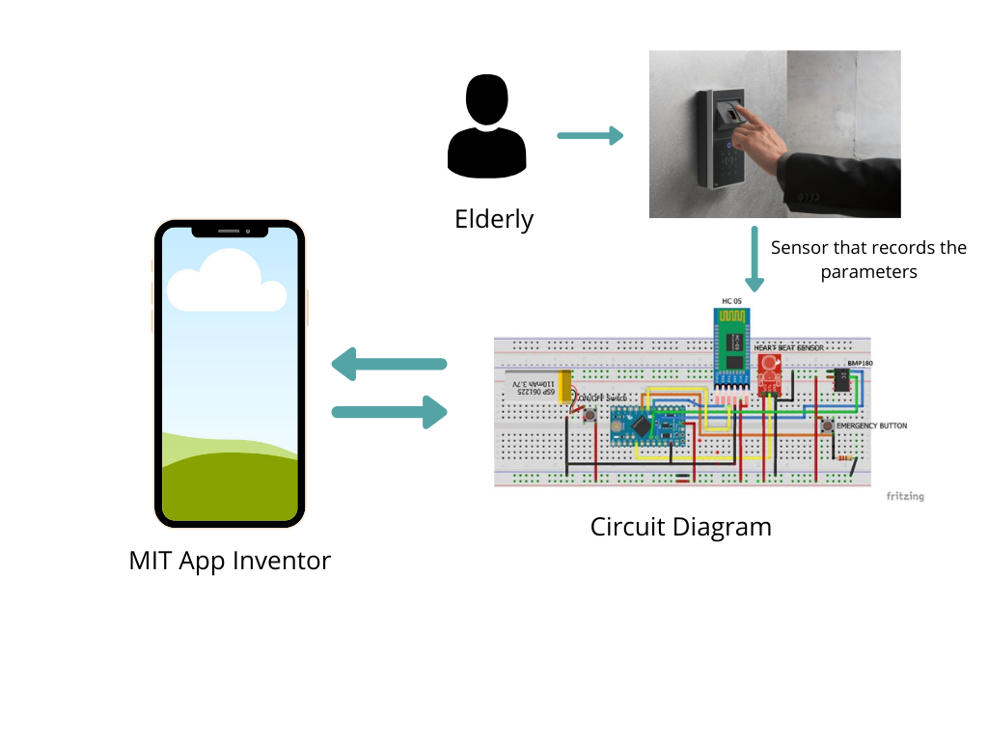

The figure above illustrates a circuit with several components: a Bluetooth transceiver for communication, an Arduino Pro Mini pre-programmed for control, a heart rate sensor to monitor the user's heart rate, a BMP180 sensor for measuring atmospheric pressure, and two buttons—a power switch and an emergency button.

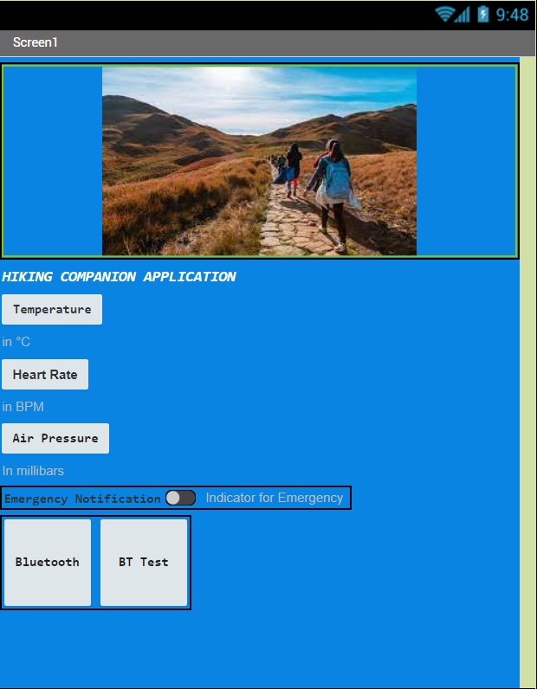

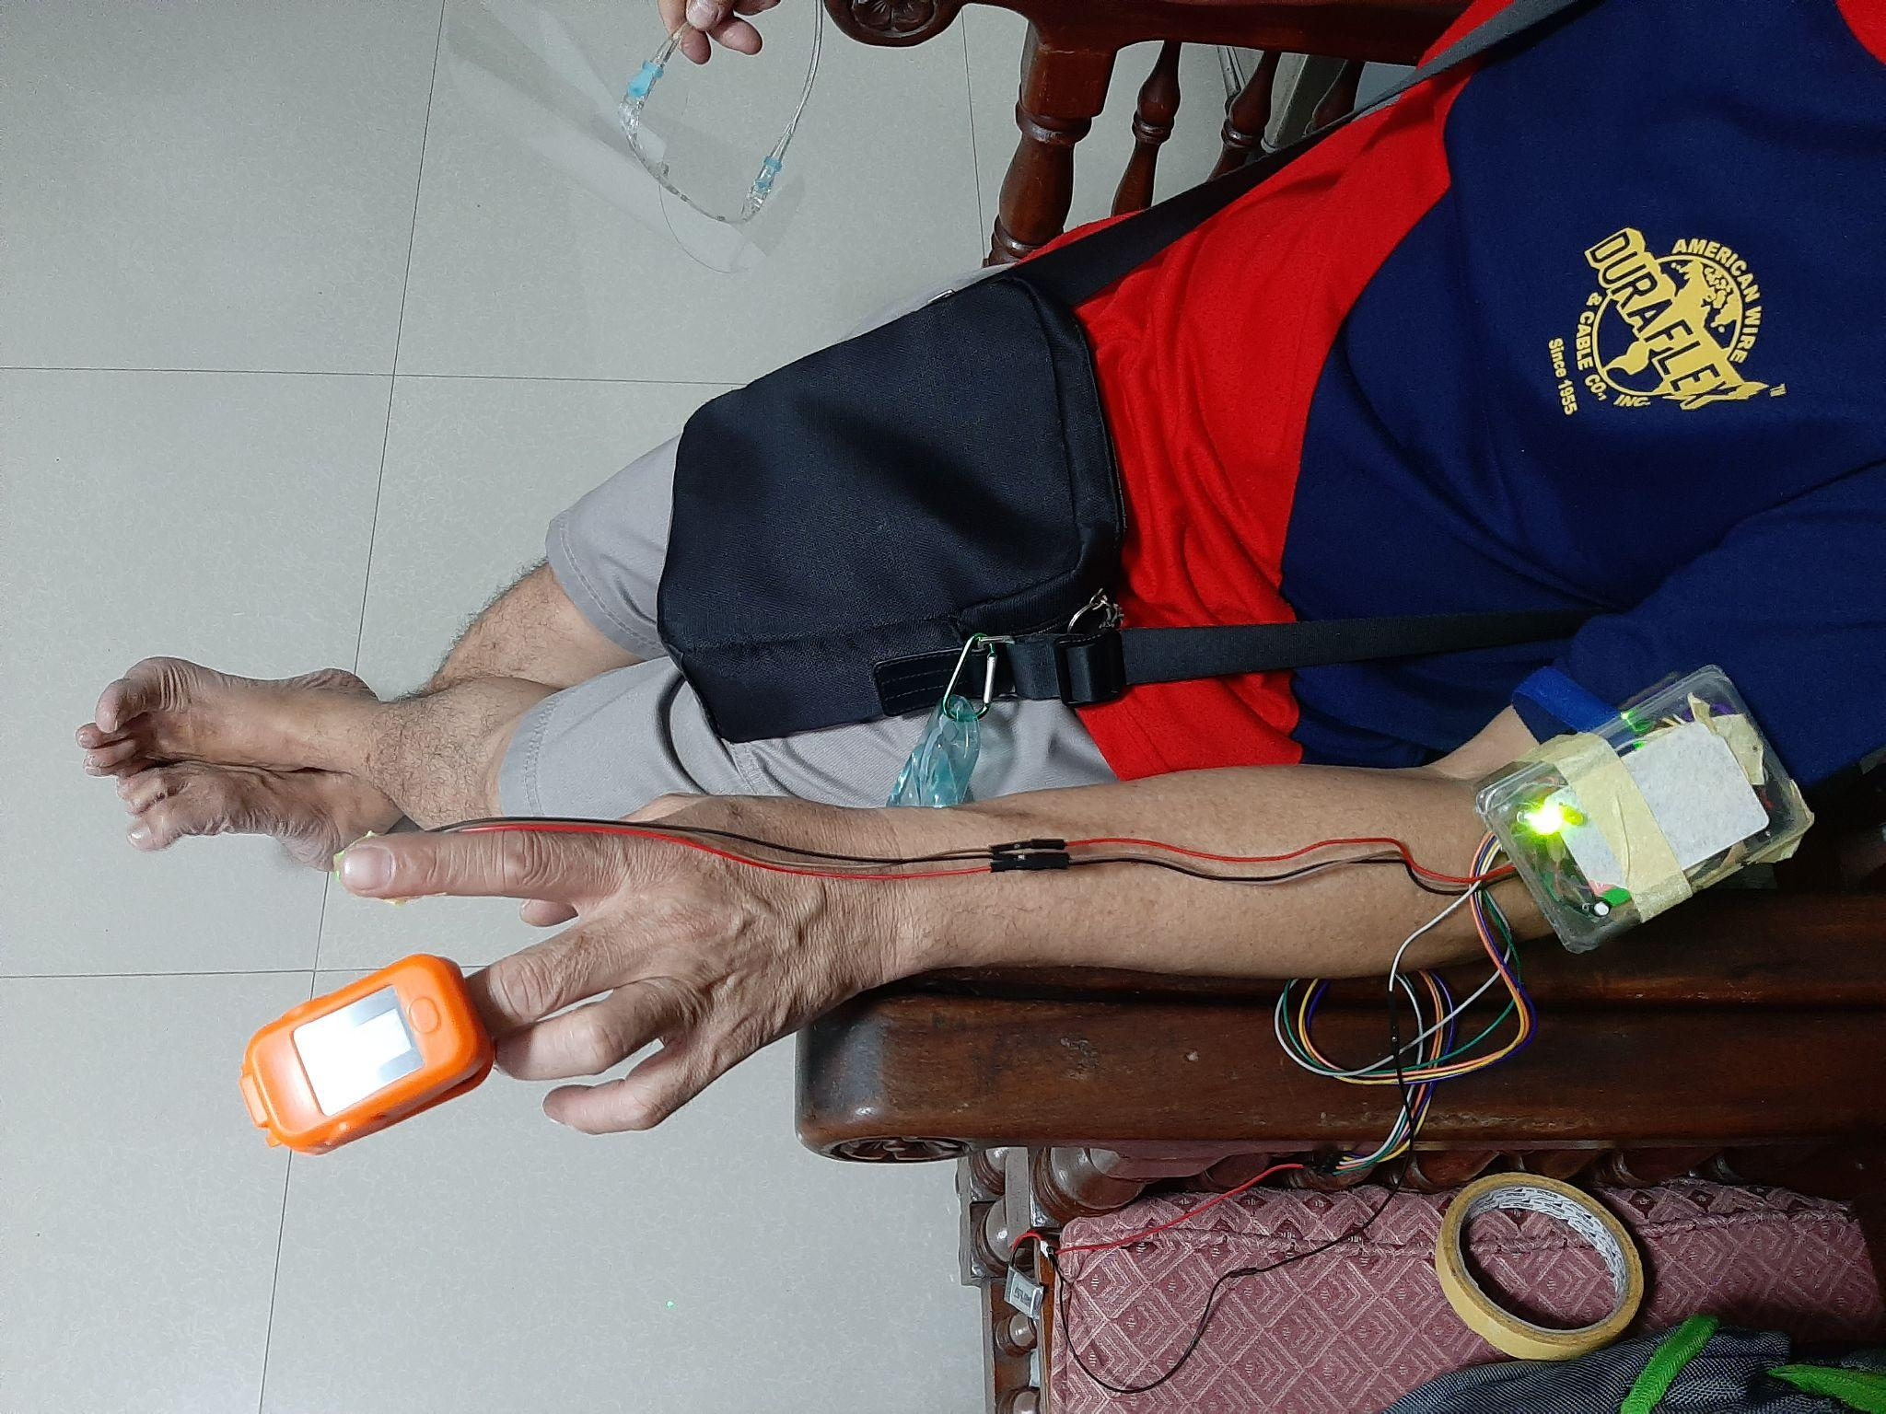

The GUI developed in MIT App Inventor for a mobile device includes five buttons and a slider. It allows users to request and display temperature, heart rate, and altitude measurements from a health band connected to Arduino. If any measurement falls outside acceptable parameters, an emergency notification alerts the mobile user, indicating potential wearer distress or unsuitable environmental conditions. The notification feature continuously monitors wearer conditions by sending data to Arduino.